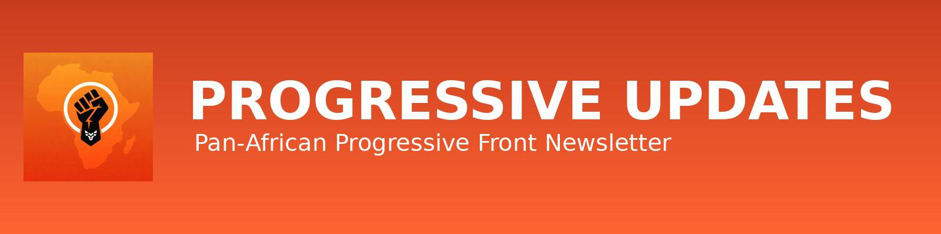

MONTHLY NEWSLETTER
SEPTEMBER 2026

THEME OF THE MONTH
The theme for this month's newsletter is Youth Mobilisation, Organised Struggle, and the Political Agency of a New Generation
ONE AFRICA, ONE PEOPLE…

DISCLAIMER
This newsletter is issued by the Pan-African Progressive Front (PPF) for information, education and public engagement purposes only. The views, positions and analyses expressed reflect the political and policy perspectives of PPF and its leadership, and do not necessarily represent the positions of partner institutions, participating organisations or individual contributors (unless referenced). All materials contained herein are intended to support public dialogue, Pan-African solidarity and civic participation.
Pan-African Progressive Front (PPF) | www.pp-front.com | Page 1

EDITORIAL
FROM GEN Z MOMENT TO PAN-AFRICAN MOVEMENT: WHY AFRICA'S FREEDOM CANNOT BE OUTSOURCED TO A GENERATION
A PPF Editorial for August 2026
There is a mood moving through the world's youth right now, and it is easy to mistake it for a movement. From city to city, young people are filling the streets faster than any single organisation can claim credit for. Commentators have rushed to name it: the Gen Z revolution. A generation, we are told, is rising as one, borderless and leaderless, armed with a phone and a grievance. It makes for a powerful headline. It does not make for a strategy.
This was the tension sitting underneath the International Youth Forum, "Africa's Freedom Is in Our Hands," convened by the Pan-African Progressive Front on September 5 at the ISSER Conference Hall in Legon. More than 250 young people from 11 countries did not gather to celebrate a generational vibe. They gathered to argue about what comes after it.
Comrade Blaise Tulo put the argument plainly: youth is not a class. Age is not a political program. A 19-year-old mine worker in Marikana and a 19-year-old heir to a mining concession are both, technically, Gen Z. They are not on the same side of history, and no hashtag will put them there. When a movement organises around generation alone, it borrows energy it cannot discipline and builds solidarity it cannot sustain. The government waits it out or co-opts the loudest voice in the room. The structures of debt, dispossession and foreign control that produced the anger in the first place are left standing, untouched, ready to absorb the next outburst in five years' time.
This is not an argument against youth uprising. It is an argument against youth uprising that stops at the uprising. Comrade Kwesi Pratt Jnr. intervention made the constructive half of the case: that young Africans have both the standing and the obligation to lead the fight for reparatory justice, precisely because they are the generation inheriting the poverty, unemployment and inequality that slavery, colonialism and neocolonialism engineered and never repaired. Leadership, in his framing, is not a mood. It is a discipline built through study, organising and sustained civic action.
Read together, the speakers at the Forum were making one argument from two directions. The spontaneous energy filling Africa's squares and timelines is real, and it is justified. But spontaneity without organisation is a wave that breaks and recedes, and imperialism has gotten very good at waiting out waves. What does not recede is a trade union with a mandate. A student federation with elected leadership. A political front with a programme that survives past the news cycle that produced it. This is what the forum was actually convening: not a generation, but the political infrastructure a generation needs if its anger is going to become policy rather than a memory.
This is also why the forum's organisers were careful not to set youth agency against the continent's governments, but to press for both together. Ghana's own reparations push at the United Nations, its chairmanship ambitions at the African Union, its stated commitment to reparatory justice as a matter of law rather than sentiment, these are not backdrops to youth mobilisation. They are the terrain on which youth organising either finds leverage or wastes itself shouting at a wall. A generation that builds real organisations can hold its own governments accountable to these commitments and push them further. A generation that only trends can be praised in a communique and ignored in the budget.
So the honest message coming out of ISSER Hall at Legon is not a celebration. It is a warning wrapped in an invitation. Do not mistake being online at the same time as your peers for being organised with them. Do not let the size of a hashtag substitute for the strength of a structure. The Gen Z moment sweeping the world is a genuine sign that the old order is losing its grip on the imagination of the young. But a mood does not seize the state, does not cancel a debt, does not repatriate a resource. Organising and joining movements does.
To the youth of this continent, the call from this forum is not to sit out the moment. It is to refuse to join it emptyhanded. Walk into the union hall, the student unions, the progressive front, before you walk into the square. Bring a programme with you, not just a placard. Africa's freedom was never going to be delivered by a generation acting alone. It will be built, as it always has been, by the organized people collectively.
#YouthIsNotAClass #OrganiseDontJustMobilise #AfricasFreedomIsInOurHands #ReparatoryJusticeNow

NEWS & STATEMENTS
INTERNATIONAL YOUTH FORUM – “AFRICA’S FREEDOM IS IN OUR HANDS”

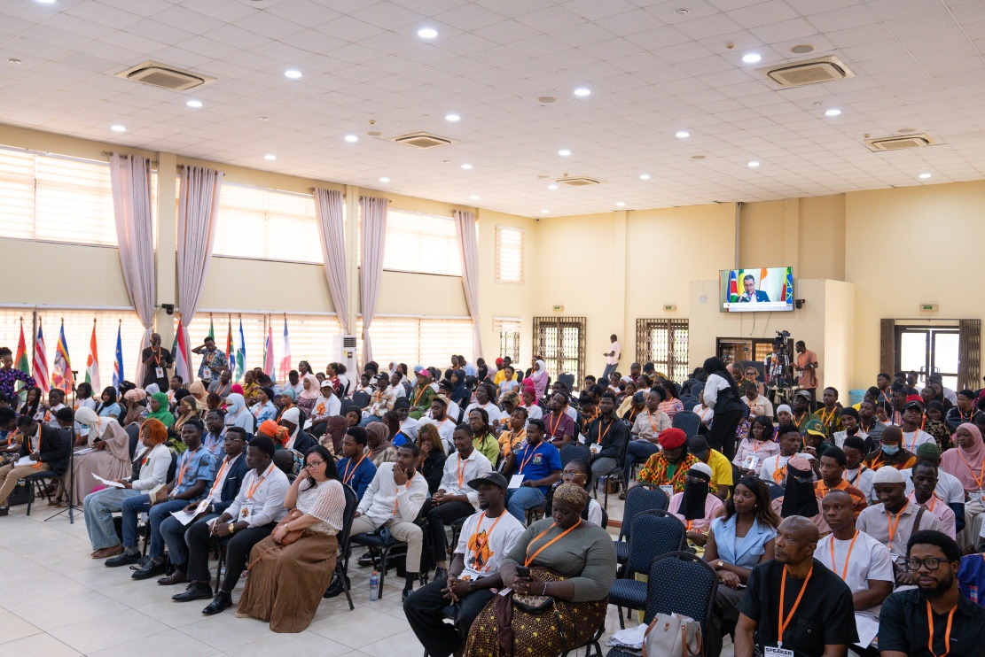
On September 5, 2026, the Pan-African Progressive Front (PPF) convened the International Youth Forum, “Africa’s Freedom Is in Our Hands,” at the ISSER Conference Hall of the University of Ghana, Legon. The forum brought together more than 250 young Africans from 11 countries to examine Africa’s debt crisis, reparatory justice and the continuing struggle against imperialism.
Discussions at the forum connected Africa’s present economic challenges to the historical and continuing effects of slavery, colonialism and external economic domination. Speakers argued that the reparations agenda must extend beyond financial compensation to address questions of economic justice, control over Africa’s natural resources, debt cancellation and political self-determination.
The forum also placed emphasis on the need for young Africans to move beyond periodic protests and discussions towards sustained organisation and collective action. Participants were encouraged to build durable structures capable of advancing Africa’s economic sovereignty, political independence and broader liberation.
CLICK THE LINK FOR THE FULL STORY

“YOUTH IS NOT A CLASS”: COMRADE BLAISE TULO SHARPENS THE REPARATIONS DEBATE AT PPF YOUTH FORUM

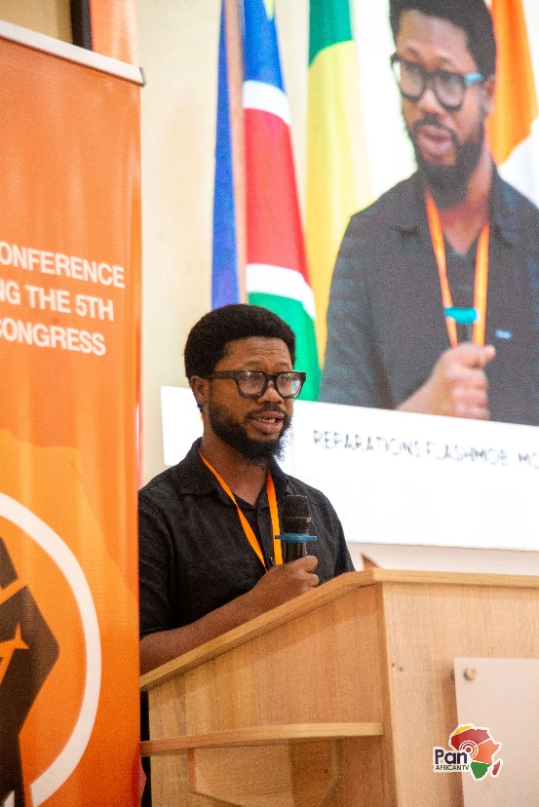
In his intervention, Comrade Blaise Tulo, Head of the International Relations Directorate of the Socialist Movement of Ghana (SMG), sharpened the debate on reparatory justice at the Pan-African Progressive Front (PPF) Youth Forum.
Tulo argued that mobilising young people on the basis of age alone cannot produce lasting political change. Instead, he called for organised movements rooted in trade unions, student organisations and progressive political structures to advance Africa's liberation. On reparations, he maintained that justice must extend beyond financial compensation to confront the enduring economic and political systems created by slavery and colonialism, including debt dependency and unequal global economic relations.
READ FULL STORY

THERESA BOATENG URGES AFRICAN YOUTH TO LEAD THE FIGHT FOR REPARATORY JUSTICE

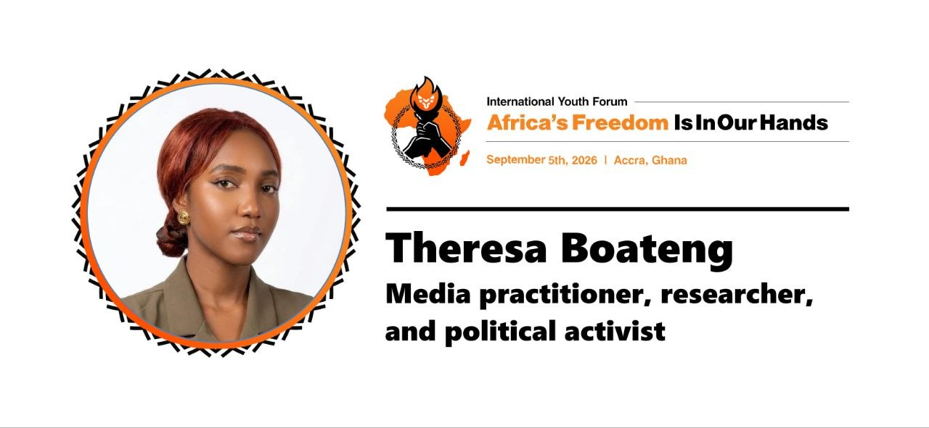
At the PPF International Youth Forum on Debt and Reparations, Theresa Boateng called on African youth to take a leading role in the struggle for reparatory justice. She argued that the effects of slavery, colonialism and neocolonialism continue to influence poverty, unemployment, inequality and other challenges facing Africa. She encouraged young people to study Africa’s history, mobilize their communities and take action through research, education and activism.
CLICK THE LINK FOR THE FULL STORY

HEAD OF MISSION OF PALESTINE VISITS PPF
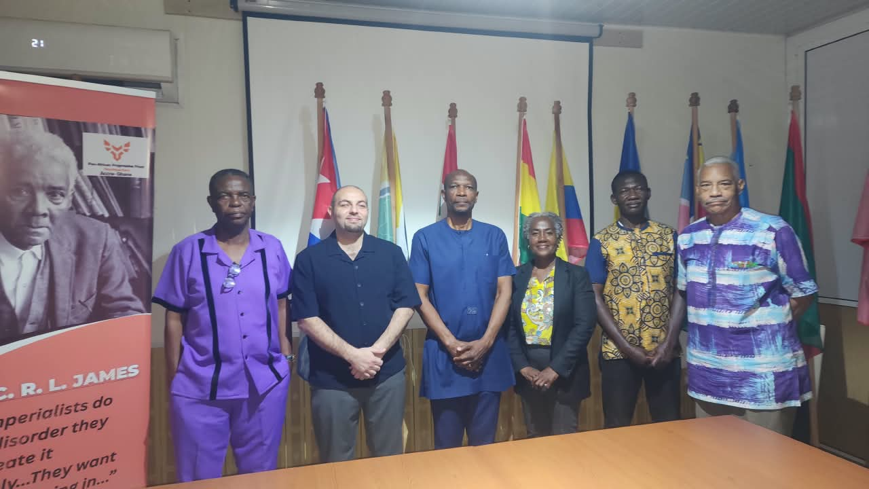
The Head of Mission of the State of Palestine paid a courtesy visit to the Pan-African Progressive Front (PPF) to strengthen solidarity and cooperation between Palestine and African progressive movements. The meeting focused on Palestinian liberation, African solidarity, anti-imperialism and self-determination. Both sides discussed the importance of building stronger connections between African and Palestinian struggles against colonialism and foreign domination.
The visit highlighted the PPF’s support for Palestinian rights and sovereignty and the value of continued cooperation between Palestine and Pan-African organizations.
READ MORE
KWESI PRATT JNR CALLS FOR SOCIALIST PAN-AFRICAN UNITY

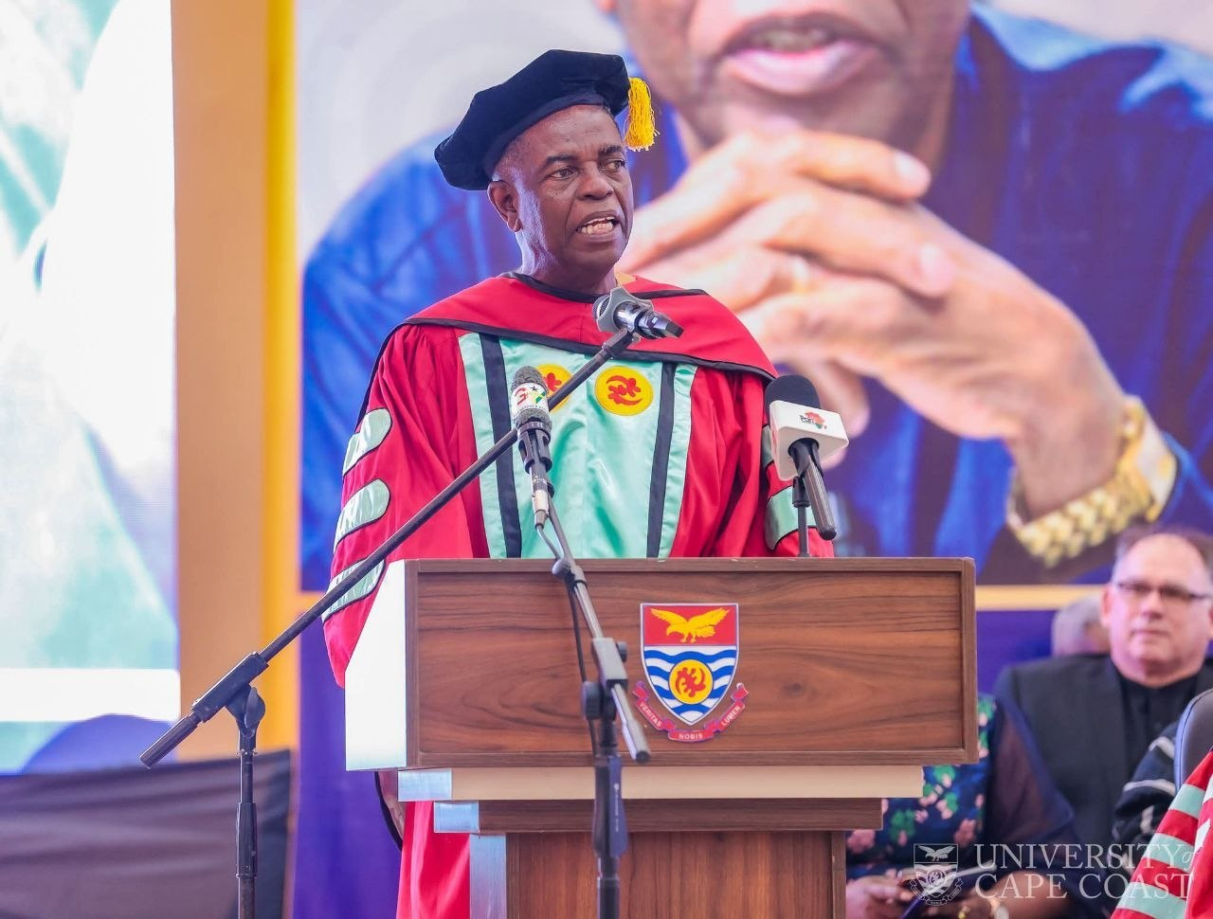
The Secretary-General of the Socialist Movement of Ghana and Coordinating Committee Member of the Pan-African Progressive Front, Comrade Kwesi Pratt Jnr., has called for a united Africa based on Pan-Africanism and scientific socialism while delivering the 15th Kwame Nkrumah Memorial Lectures at the University of Cape Coast (UCC).
UCC subsequently awarded Comrade Kwesi Pratt Jnr. an honorary Doctor of Letters (D.Litt.) in recognition of his decades of contributions to journalism, public discourse, African emancipation and Pan-Africanism.
Drawing on the political ideas of Osagyefo Dr. Kwame Nkrumah, Comrade Pratt stressed that African liberation requires continued commitment to continental unity, self-determination and economic independence. He also urged universities to go beyond the transfer of knowledge and play an active role in addressing the social, economic and political challenges facing society.
CLICK THE LINK FOR FULL STORY

PRESIDENT MAHAMA TELLS UN GHANA WILL PRESS FOR REPARATIONS, PALESTINIAN RIGHTS AND AN END TO CUBA EMBARGO

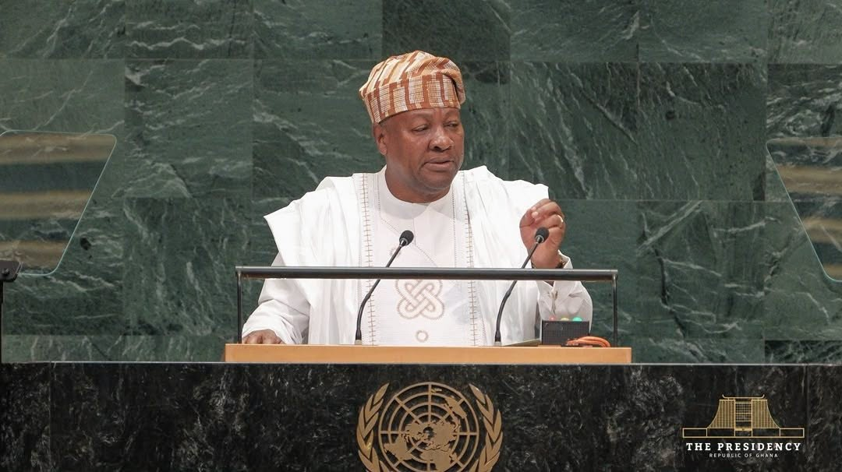
President John Dramani Mahama has reaffirmed Ghana’s commitment to reparatory justice, Palestinian rights and the lifting of the economic embargo on Cuba in his address to the 81st United Nations General Assembly.
Speaking at the UN, President Mahama called for the international community to move beyond acknowledging the history of the transatlantic slave trade towards addressing and repairing its enduring consequences. He outlined a reparations agenda centred on structural change, including fairer trade rules, an end to predatory resource extraction, relief from unsustainable debt, fairer access to international credit and greater value addition to Africa’s raw materials on the continent.
President Mahama, who serves as the African Union’s Champion for Reparatory Justice, also highlighted Ghana’s efforts to advance the global reparations agenda following the Accra consultative conference held in June 2026. He noted that the process has contributed to the establishment of global advisory, expert and legal mechanisms focused on reparatory justice and the restitution of cultural heritage.
On Palestine, President Mahama reaffirmed Ghana’s recognition of the State of Palestine and its support for a two-state solution, while calling for respect for international humanitarian law. He also reiterated Ghana’s call for the immediate lifting of the economic embargo on Cuba.
The address further outlined Ghana’s priorities on African representation at the UN Security Council, debt, climate finance and deeper continental integration. President Mahama said Ghana would use its forthcoming 2027 African Union chairmanship to advance stronger continental cooperation, accelerate implementation of the African Continental Free Trade Area and promote greater African control over the processing and value of the continent’s natural resources.
Read full story
Pan-African Progressive Front (PPF) | www.pp-front.com | Page 8

TUC SETS RED LINES FOR GHANA’S CONSTITUTION
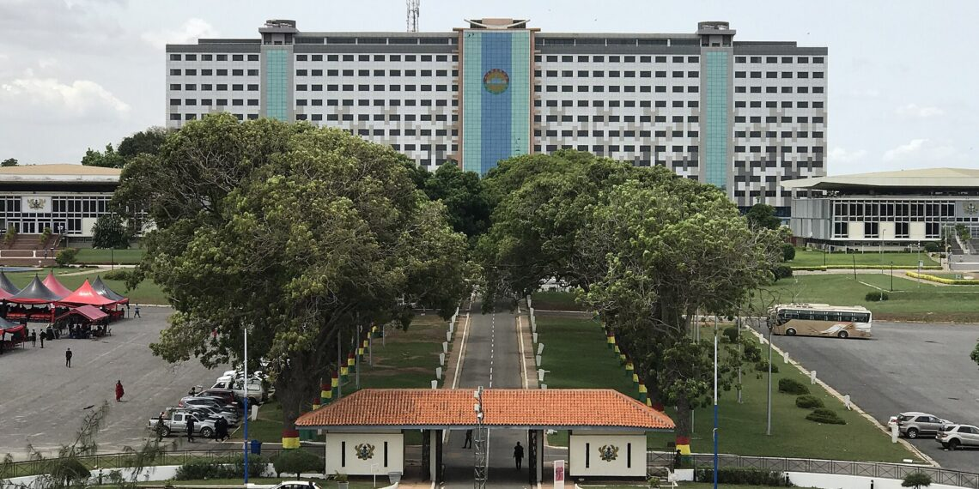

The Trades Union Congress (TUC) has outlined the constitutional reforms it supports and those it opposes. It supports reducing presidential appointment powers, strengthening Parliament’s oversight, and giving local governments greater independence.
The TUC supports five-year presidential terms only alongside stronger accountability measures, but firmly rejects allowing dual citizens to serve as MPs. It also opposes central government controlling candidates for District Chief Executive elections.
On natural resources, the TUC wants greater public and parliamentary control, including Parliament’s prior approval of major natural-resource agreements. Overall, its position focuses on limiting executive power, strengthening democratic accountability,
READ MORE

UN RESOLUTION ON AFRICA’S TRUE SIZE

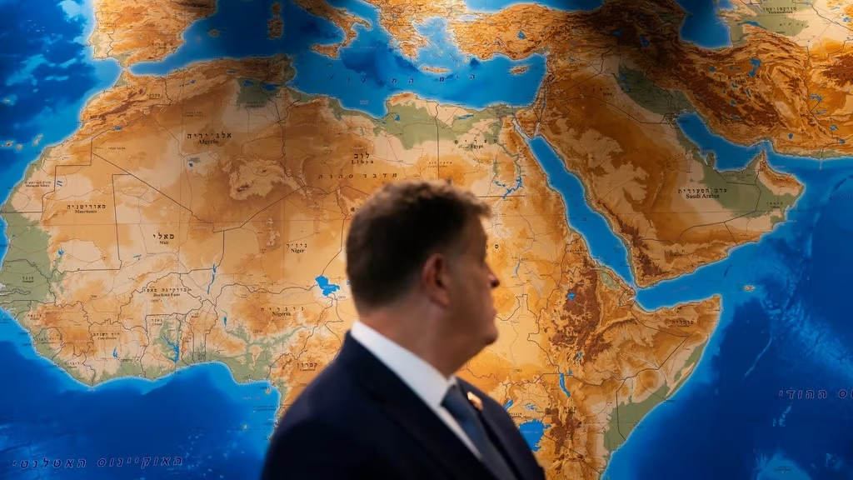

The UN General Assembly adopted an African-led resolution, sponsored by Togo, calling for more accurate world maps that better represent the size of Africa. It passed 164–1, with six abstentions; the United States was the only country to vote against it.
The resolution focuses on scientific and educational accuracy, encouraging schools, universities and organisations to explain the limitations of different map projections. It highlights how the commonly used Mercator projection makes regions near the Equator, particularly Africa, appear smaller than they actually are. Africa is about 14 times larger than Greenland, despite often appearing similar in size on Mercator maps. Togo argued that correcting these distortions could help improve how Africa is understood and represented globally, while the US representative described the initiative as an “ideological project.”
READ MORE

SOCIALIST MOVEMENT OF GHANA MARKS NKRUMAH’S 117TH BIRTHDAY
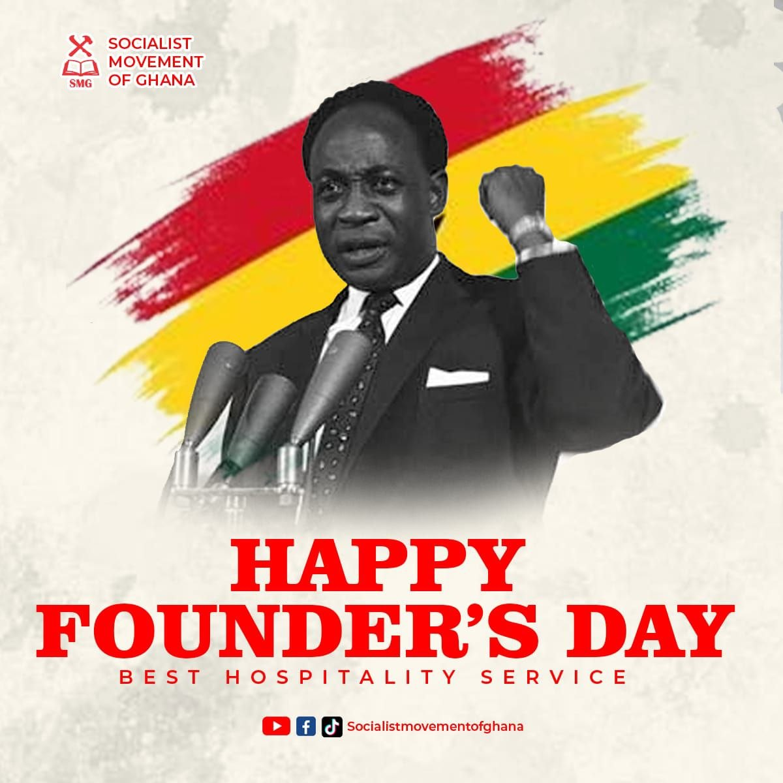The Accra Collective of the Socialist Movement of Ghana (SMG) has marked the 117th birth anniversary of Osagyefo Dr. Kwame Nkrumah with a call for renewed commitment to national liberation, economic sovereignty and Pan-African transformation. In a statement issued on September 21, the movement described the commemoration not simply as an occasion to remember Nkrumah, but as an opportunity to continue what it described as the unfinished struggle for Africa’s liberation and transformation.
The statement highlights Nkrumah’s role in mobilising workers, farmers, market women, youth and other sections of the population in the struggle for Ghana’s independence. It also recalls his development programme, including investments in education, healthcare, infrastructure and industrialisation, as part of his broader vision for an economically independent Ghana.
SMG has further drawn attention to the continuing challenges of economic dependence, including Africa’s reliance on raw-material exports, debt, austerity and external financial influence. The movement has called for greater democratic control over Ghana’s natural resources and their use to support industrialisation, decent employment and social development.
The statement also expresses solidarity with working people and calls for stronger labour rights, secure employment, a living wage and greater economic justice, while highlighting the role of young people and women in building a transformed society.
Read Full Story Here
MOUVEMENT HARBISTE ARTICLE ON “BAB EL-MANDEB: AFRICA AS THE RECEPTACLE OF OTHER PEOPLE’S HISTORY,”
The article, “Bab el-Mandeb: Africa as the Receptacle of Other People’s History,” examines the current situation around the Bab el-Mandeb Strait and argues for a fundamentally African perspective on a region that is too often discussed primarily through Middle Eastern, European or Western narratives.

The current crisis in Yemen is not distant from Africa. Its consequences are already reaching Djibouti and the wider Horn of Africa, including through displacement, maritime insecurity, trade and regional economic pressures. Yet Africa is frequently presented as the place where the consequences of external crises are received rather than as an actor with its own history, interests and strategic agency.

Bab el-Mandeb is not simply a passage between the Arabian Peninsula and Africa. It is part of a much older African and Indian Ocean world of trade, migration, political power, religious exchange and cultural interaction. The article therefore looks beyond the conventional Middle East–Africa divide and asks what changes when the story begins from the African side of the Red Sea.

It also considers Djibouti’s strategic position and the growing importance of African regional connectivity, including the DESSU corridor, to argue that Bab el-Mandeb can be understood not only as a gateway through which the world reaches Africa, but also as a gateway through which Africa reaches the wider world.

I believe this perspective is particularly relevant to a Pan-African publication because the question is ultimately not only about geography or current events. It is about who has the power to define Africa’s place in the world, whose history is placed at the centre, and from whose perspective African realities are interpreted.
Read the full article here

JAMAICA FILES SLAVERY REPARATIONS PETITION
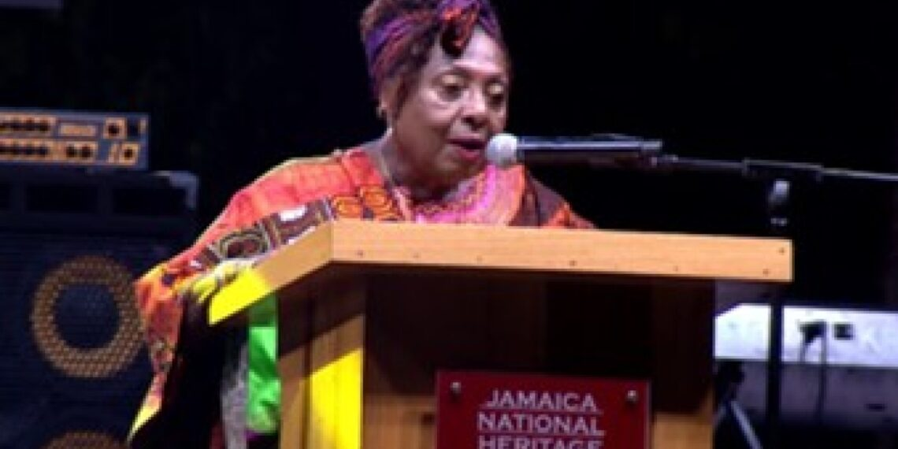
Jamaica has formally petitioned King Charles III to refer three legal questions about Britain’s role in the transatlantic slave trade to the Judicial Committee of the Privy
The questions ask whether the forced transportation and enslavement of Africans in Jamaica were lawful, whether they constituted crimes against humanity, and whether Britain has a legal obligation to provide reparations.
The petition, led by Culture Minister Olivia Grange, does not directly demand compensation. Instead, Jamaica is seeking a legal opinion that could establish Britain’s responsibility and provide a basis for future reparatory action. The move is supported by CARICOM and forms part of Jamaica’s wider campaign for reparatory justice and cultural
READ MORE
Pan-African Progressive Front (PPF) | www.pp-front.com | Page 11
CHINESE FORCED LABORERS SEEK REPARATIONS

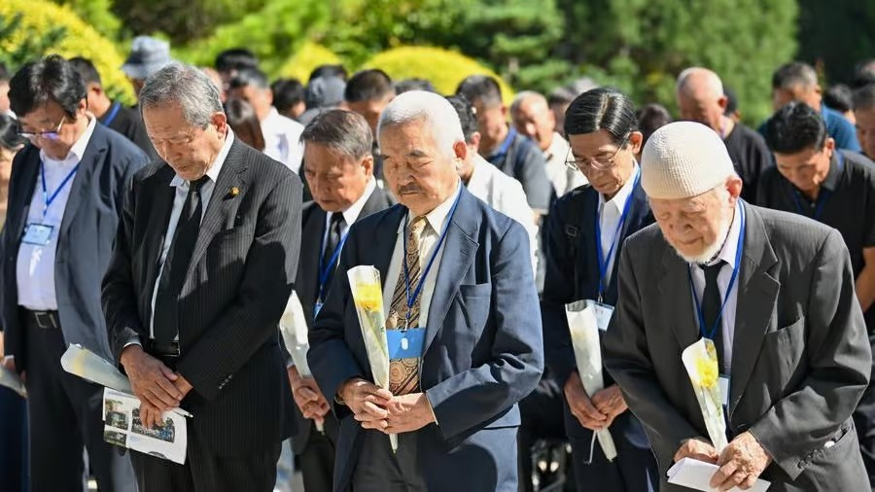
About 50 family members and descendants of Chinese wartime forced laborers filed a lawsuit in a Chinese court against six Japanese companies, seeking compensation for suffering and deaths caused by forced labor during Japan’s occupation of China.
The plaintiffs are demanding about $55,000 each, along with a public apology in Chinese and Japanese media. The companies are accused of benefiting from the forced-labor system.
The case is part of a long-running struggle for reparations and acknowledgment of Japanese wartime atrocities. Previous cases in Japan have generally been dismissed, while China maintains that individuals still have the right to seek justice.
READ MORE

BRICS CONDEMNS CUBA BLOCKADE AND IRAN ATTACKS
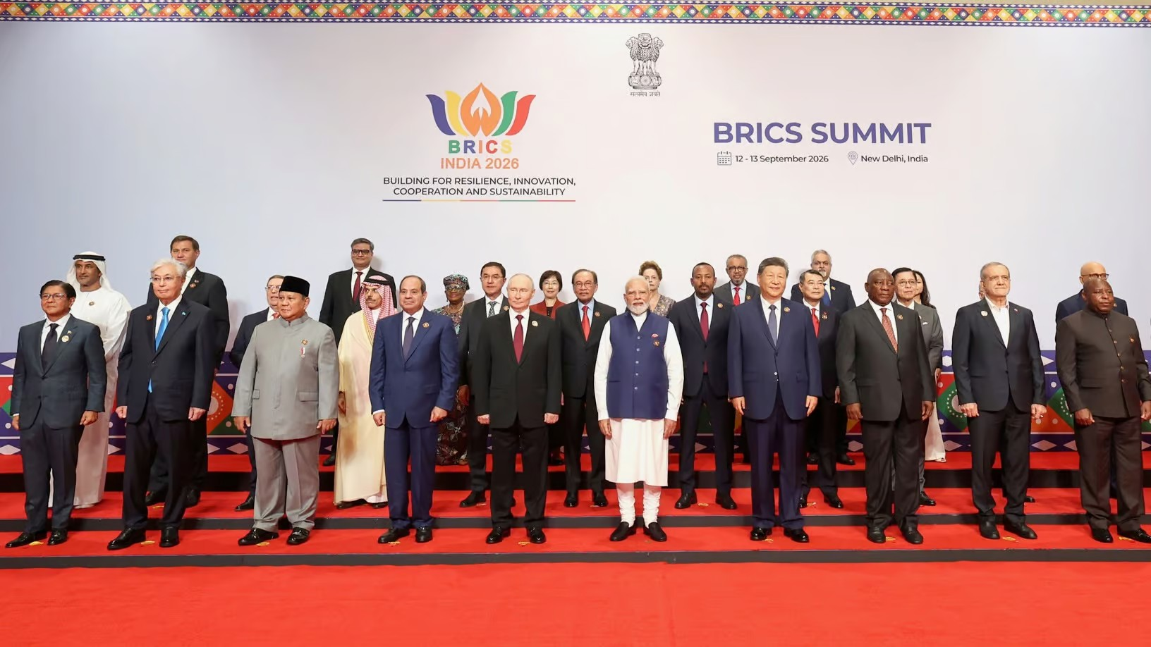
At the 18th BRICS Summit in New Delhi, member countries called for an end to the U.S. blockade of Cuba, citing its economic, energy and humanitarian effects.
The BRICS declaration also expressed concern over attacks on Iran, including strikes on civilian infrastructure and safeguarded nuclear facilities, and called for respect for international law and diplomatic solutions. It condemned unilateral sanctions that are not authorised by the UN and called for greater reform of global institutions.
The summit also reaffirmed support for Palestinian rights, opposition to forced displacement in Gaza, and a more representative and multipolar international system.
CLICK FOR FULL STORY

ONE AFRICA!

ABOUT PPF
The Pan-African Progressive Front (PPF) is an international non-governmental organisation headquartered in Accra, Ghana. It stands at the forefront of the fight for Africa's unification and is committed to coordinating and supporting progressive movements across Africa and the diaspora, with the goal of advancing the true interests and future of the continent.
Inspired by the vision of Dr. Kwame Nkrumah and other Pan-Africanists, PPF believes that Africa's destiny must rest in the hands of its own people, and that its future lies in its political and economic unity — serving as the bedrock of our strength and continental sovereignty.

CONTACT & CONNECT WITH US

WEBSITE | https://pp-front.com/
EMAIL | panafricanprogressivefront@gmail.com
FACEBOOK | https://www.facebook.com/share/1AfibnotEf/
X (TWITTER) | https://x.com/PanAfrican_PF
INSTAGRAM | https://www.instagram.com/panafrican_pf/
TIKTOK | https://www.tiktok.com/@panafrican_pf

JOIN THE PPF WHATSAPP COMMUNITY →



ISSUED BY
PAN-AFRICAN PROGRESSIVE FRONT (PPF)
SECRETARIAT
Accra, Ghana • September 2026

